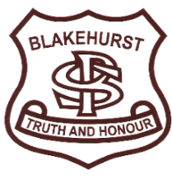
BLAKEHURST PUBLIC SCHOOL
Dewrang St, Carss Park, NSW, 2221
Tel: (02) 9546 1555
Fax: (02) 9547 1796
Email: Blakehurst-p.school@det.nsw.edu.au
Website: www.blakehurst-p.schools.nsw.edu.au

Instructions for Accessing Google Classrooms
Please refer below for details on how to access your child’s online student portal. Each student’s portal is run by the NSW Department of Education, and includes links to your child’s own email account, as well as links to commonly used online programs. Specific learning material for your child’s class can also be accessed from this portal.
Your child will need to enter his/her User Identification and Password to access the activities on the portal. ‘Google Classroom’ is used as a way to deliver daily learning tasks to students. Students can post comments and questions for their teacher to answer, in addition to messages for their class.
If a student needs assistance to access their class site or has forgotten his/her login details, the class teacher can be contacted by email. Please refer to the individual class pages sent to families through Skoolbag.
STEP 1 : Google “det student portal”  Alternatively, you can go to:  https://education.nsw.gov.au/  and use the login menu to select ‘student portal’ | 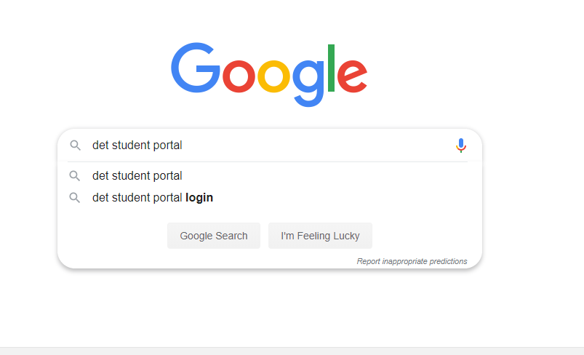
STEP 2: Click on “DET Portal” | 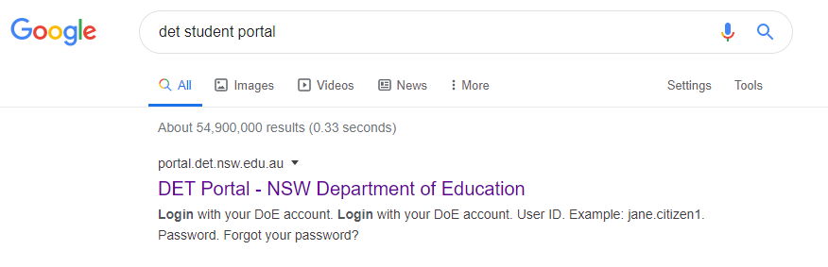
STEP 3: Enter your user ID and password as given. | 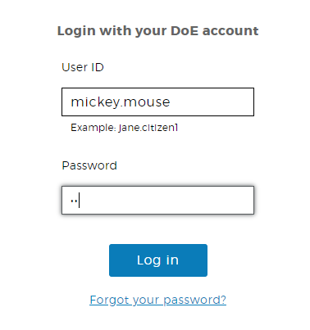
STEP 4: Your child’s student portal should appear as pictured. It is from this home screen that email, apps and websites can be accessed. | 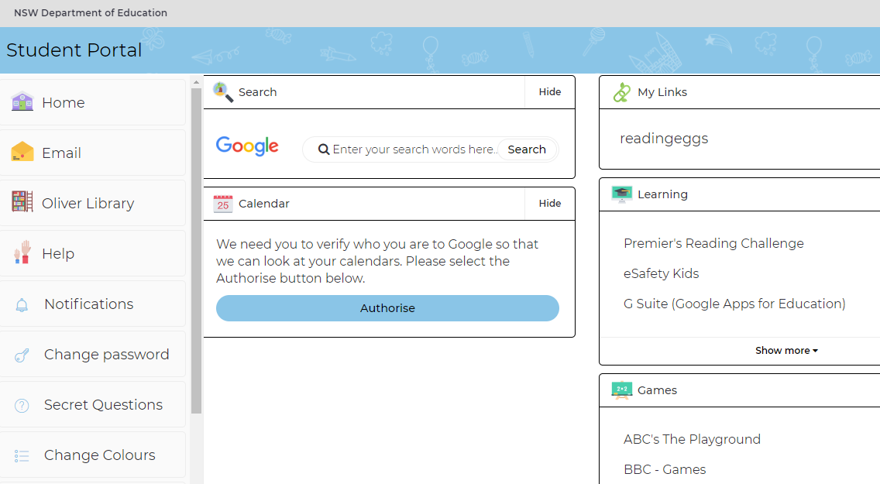
STEP 5: In order to access ‘Google Classroom,’ first click on ‘G Suite (Google Apps for Education) under the learning table on the portal home page. | 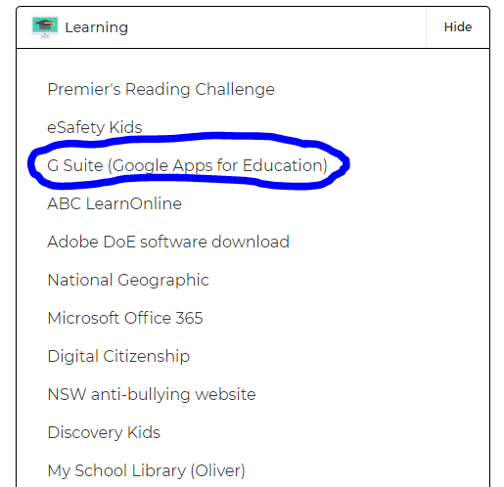
STEP 6: Click on the ‘Classroom’ icon.  The other applications such as ‘Docs’ and ‘Drive’ can be used to create and save work. Feel free to investigate and utilise these valuable tools. | 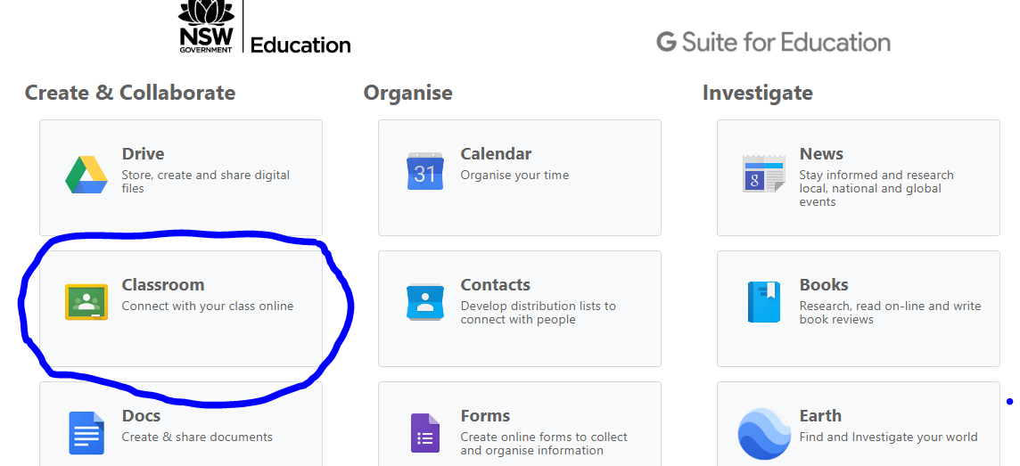
STEP 7: Select the appropriate class, eg - ‘KW 2020’ – your child has already been added to this virtual class by the teacher. All learning tasks and messages will appear here. | 