Getting Started with ePlatform by Wheelers
- Our eBooks can be seen 2 different ways, through internet browser (Chrome, Safari, Internet Explorer etc.) going to Oliver Library in our Student and staff portals and by using the free ePlatform App (Apple and Android).
https://help.eplatform.co/hc/en-us/articles/115003869287-eLibrary-Basics
https://help.eplatform.co/hc/en-us/articles/115003984988-Downloading-Mobile-Apps
To use the ePlatform App

- Once you’ve installed the ePlatform by Wheelers app onto your device you will be prompted to “Find your Library”, search for Blakehurst Public School.
https://help.eplatform.co/hc/en-us/articles/115003985868-Getting-Started-with-ePlatform-app

- To browse the catalogue

https://help.eplatform.co/hc/en-us/articles/115003889327-Browsing-eBook-Catalogue

- To borrow and return

https://help.eplatform.co/hc/en-us/articles/360002373352-How-can-I-borrow-or-return-Audiobooks-or-eBooks-

- If prompted for your User ID, use your student portal username and password.

Hints:
Turning pages can be tricky at first, try swiping or tapping the screen, if using a keyboard the arrow keys should work too.
When using the Browse button you can narrow your search by availability, age etc.

To use through Oliver Library
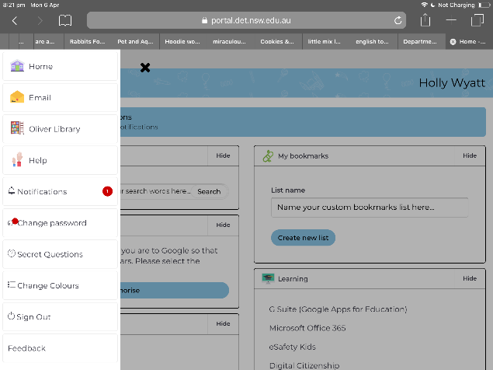
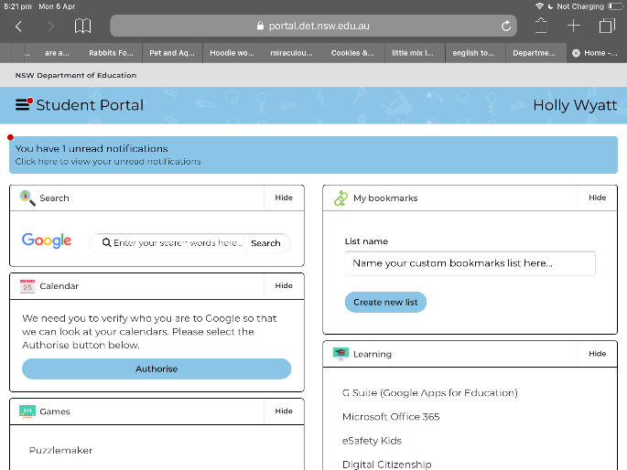
- Click on My school library in your student portal by clicking on the button with 3 lines on the top left of the screen or the Oliver Library link on the left of the screen.

- Look for books with the following icon which indicates an ebook:

- To search through our ebook collection choose Advanced Search in the Types box select ebooks, then click search.
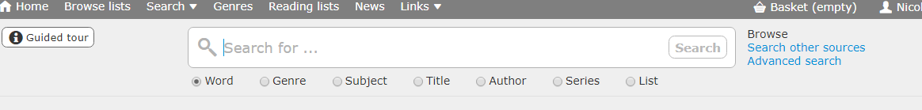

- Click on the cover or title of a book with a green tick, indicating it is available,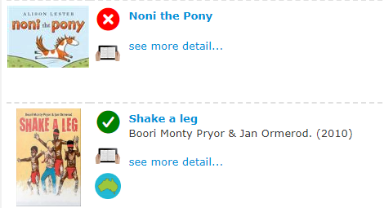
- Click on “Borrow ebook” under the cover
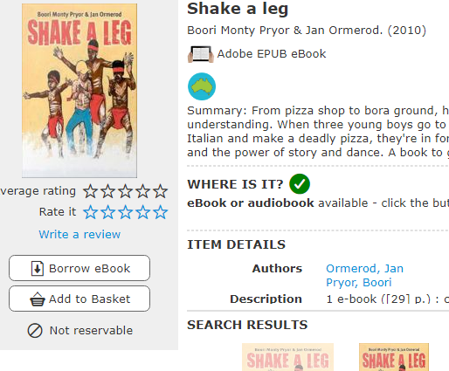

- The eBook should open in a new window. If using touch screen pages are turns by swiping, or try left and right arrows on keyboard and/or the screen, otherwise the icon with 3 bullet points on the top left may have chapter headings.
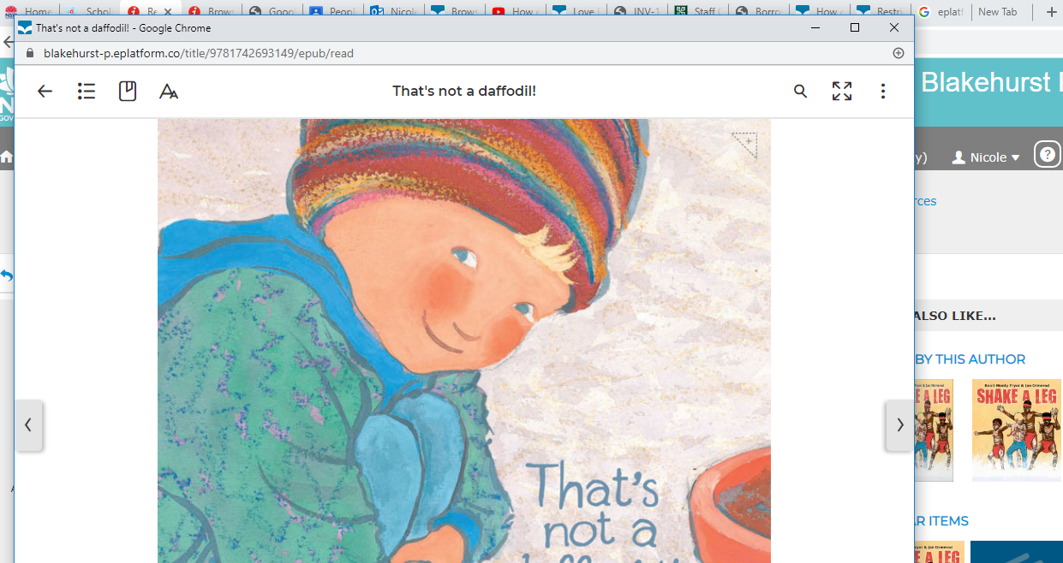

- The “Aa” letters icon allows you to see single or double page spreads, choose night settings, dyslexic settings and text sizes.
- To return using Oliver Library Click on your name and scroll down to Loans, then select Digital Loans, select the cover and click on “Return Electronic resource”.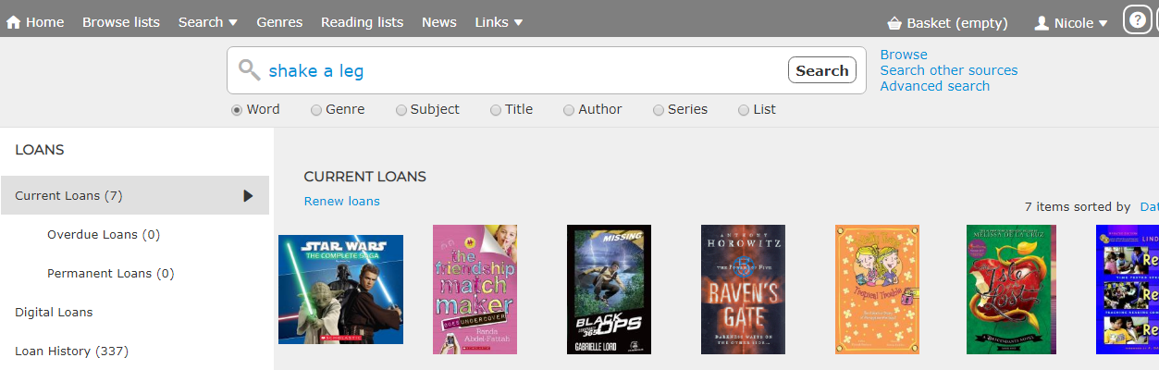

Hints and tips
- Greyed out books on the Wheelers ePlatform App mean the book is loaned out. (Wheelers is a shared collection which has grown exponentially these past weeks so at the moment popular titles are currently exhausted, they’re working to fix this problem.)
- Currently only 2 eBooks are allowed to be loaned at a time, instructions above explain how to return eBooks.
- The books have recommended age restrictions so younger students are unable to loan books which most suitable for older students.

